## Build Jenkins image

Jenkins needs to be build and deployed manually:

Note: Jenkins needs to be build outside of BNSF network as we get Jenkins:Jenkins:lts image from docker hub. It also get all Jenkins plugin and also download docker client from open internet.

**Steps**:

1. Clone GIT repo to get all required files from   
   URL : XXXXXXXXX
2. Build docker image:   
     
   docker build -t registry_name/Jenkins:latest .   
     
   Note: Make sure you’re under the Jenkins folder.
3. Docker push the image to registry, if registry is up and running or else take a backup of it.
4. ssh into AKSCluster
5. Git clone the repo again.
6. Create Jenkins Admin Username and Password:   
   Username :  
   echo -n "some-username" > ./username  
   kubectl create secret generic unkey --from-file=./username  
   Password :  
   echo -n "some-password" > ./password  
   kubectl create secret generic pwdkey --from-file=./password  
     
   Note: Don’t change the secret name as it will be used internally by another script
7. Execute the deployment.yaml which is kubernetes deployment script.  
     
   kubectl apply –f deployment.yaml  
     
   Note : Please don’t execute the deployment script without creating secret[Step 6]
8. Execute the service for Jenkins pod which was created   
   It will create 2 services, one for Jenkins and other for Jenkins slave

kubectl apply –f jenkins-service.yaml

1. Execute Jenkins rbac which creates Cluster Role admin, which internally give access to Jenkins master to trigger Jenkins salve pod.  
     
   kubectl create –f jenkins-rbac.yaml
2. Run kubectl which gives external port details of Jenkins service which we have created in Step 8.  
   Sometimes it may take couple of minutes to provide the port details.
3. Get Cluster External IP and Port which we have received on previous step and as we are using NodePort service for jenkins.  
   Port would be within the range :30000-32767
4. Use username and password which we have created on Step 6 to login as admin user.   
   There will be few configuration to be done manually such as Kubernetes configuration and kubernetes pod template with docker images.   
   Navigate to ‘Manage Jenkins -> Configure System -> Cloud -> Kubernetes’  
     
   Provide Kubernetes Master URL :  
   Command : ‘kubectl cluster-info | grep master’  
     
   Provide Jenkins Master Pod URL :  
   Command : Provides pod name :‘kubectl get pods | grep jenkins’  
     
   Provide complete information and also IP :‘kubectl describe pod jenkins-XXXXX’  
   Jenkins URL will be http://<jenkin-pod>:8080  
     
   Screenshot :  
   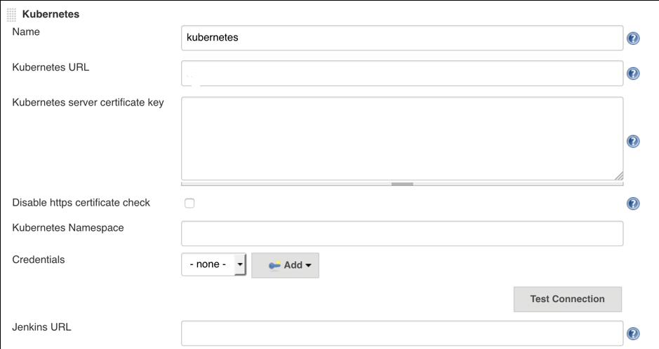
5. Under Kubernetes we have Kubernetes Pod Template, it needs to be configure manually.   
   Most important thing to fill is Docker Image, as that particular image will be used for building images we want.  
   Other is to provide label, as per label value **slave** or **master** pod will be called for building images.  
     
   Screenshot :  
   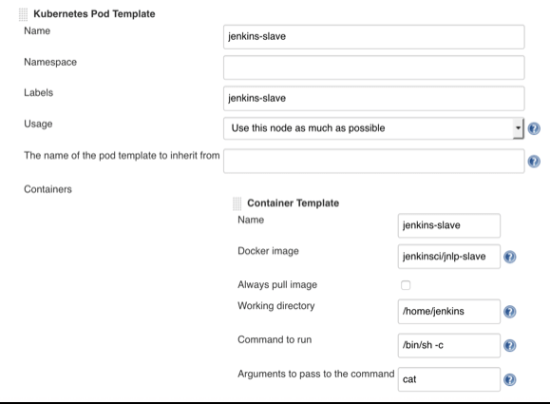
6. Try to create a job for testing purpose.  
   Make sure to fill in label under General setting for Job, which would trigger job in slave or else it will be built on master pod. 